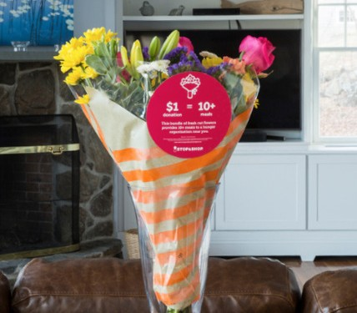

BLOOMIN’ 4 GOOD PROGRAM
Launch Day Email

DOWNLOAD IMAGES

SUBJECT: Let’s Start Raising Donations TODAY!

It’s GO Time!

Today is the first day of [month], which means it is our first day benefiting in the Stop & Shop Bloomin’ 4 Good Program! Starting today and for the entire month of [month], our organization will receive a $1 donation for every $10.99 Bloomin’ 4 Good Bouquet with the red circle sticker purchased at the Stop & Shop located at [location].

Flowers can make someone’s day, spread smiles and brighten up a room. Now they can feed the hungry, too! We can feed 10+ people in need with every Bloomin’ 4 Good bouquet sold. Why not purchase two, three or even four bouquets this month? $1 Donation = 10+ Meals. It’s as simple as that!

Please help us spread the word in our community! Share this news with family and friends, post on social media, email supporters and get the word out.

A bouquet of flowers is a great gift. This program makes it possible to make someone’s day and fight hunger at the same time.

The Bloomin’ 4 Good Bouquets with the red circle sticker are located in the floral section of the store. For more information about this program, please visit stopandshop.2givelocal.com.

Thank you for your support, [Signature]

stopandshop.2givelocal.com

