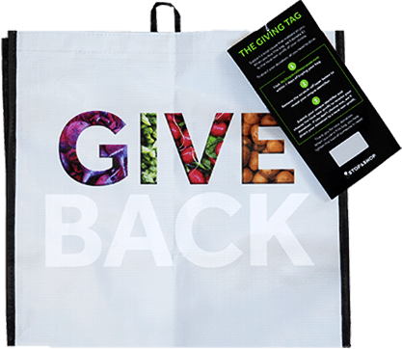GIVING TAG PROGRAM

Thank Your Supporters Email & Social Post

DOWNLOAD IMAGES
SUBJECT: Thank you! Stop & Shop Giving Tag Program

Hello,

Thank you to everyone who has visited a Stop & Shop store, purchased a Community Bag and used the attached Giving Tag to direct the $1 donation to [name of your organization]! We’ve raised a total of $[donation amount] so far.

Whether you’ve bought a bag or helped spread the word, we couldn’t have done this without you. The money generated through this program will help us to [share what you will do with the funds raised].

If you haven’t had a chance to pick up a bag yet, don’t worry! The Stop & Shop Giving Tag Program runs all year long. All you have to do is purchase the Community Bag at any Stop & Shop and follow the instructions on the attached Giving Tag to direct the $1 donation to our organization.

To learn more about this program, please visit stopandshop.2givelocal.com. Thank you for your continued support!

Share With Your Followers
Thank you! We raised $[donation amount] through the Stop & Shop Giving Tag Program! Guess what? You can continue to support us by visiting any Stop & Shop, purchasing the Community Bag and using the attached Giving Tag to send a $1 donation to us any time
throughout the year.

stopandshop.2givelocal.com

