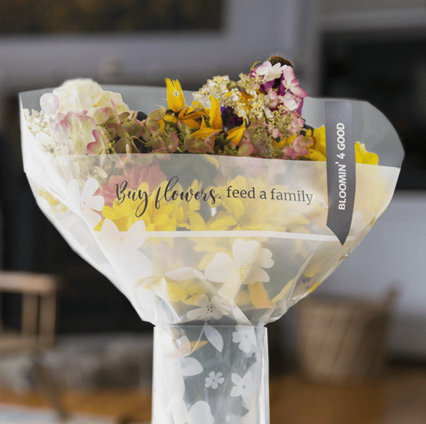

BLOOMIN’ 4 GOOD PROGRAM
Sample Email

________________________________________________________________________________________________________________________________________

DOWNLOAD IMAGES

Subject Line: Buy a Bouquet and We’ll Get $1 from Stop & Shop!

Preview Text: For all of [Month] every Bloomin’ 4 Good bouquet purchased at Stop & Shop earns us $1!

Dear [Staff/Board/Volunteers],

We are so excited to share that [organization] has been selected to benefit from Stop & Shop’s Bloomin’ 4 Good Program, created to fight hunger across the communities they serve.

For the month of [month], a $10.99 bouquet in the sleeve marked “Bloomin’ 4 Good” from the Stop & Shop at [location] will brighten a home or make someone’s day while also directing a $1 donation to [organization].

This is a great way to broaden awareness in the local community and raise donations for our organization to help fight hunger.

Let’s get started! Share the news with friends and family. Call, send emails and post on social media. The more bouquets sold, the more we can raise!
To learn more about this program, please visit stopandshop.2givelocal.com.
Best,
[Signature]

stopandshop.2givelocal.com

