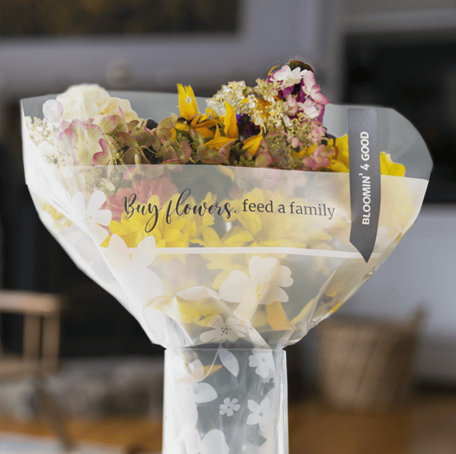

BLOOMIN’ 4 GOOD PROGRAM
Sample Press Release

__________________________________________________________________________________________________________________________

DOWNLOAD IMAGES

FOR IMMEDIATE RELEASE: [Name of organization] [Name, phone & email]

[Name of organization] Celebrates Selection as a Stop & Shop Bloomin’ 4 Good Program Beneficiary.

[City, State] – [Name of organization] has been selected as a beneficiary of the Stop & Shop Bloomin’ 4 Good Program for the month of [month].

The Stop & Shop Bloomin’ 4 Good Program, which launched in February 2021, is an easy way for shoppers to give back. Every $10.99 bouquet in the sleeve marked “Bloomin’ 4 Good” sold supports a hunger organization local to the Stop & Shop in which it was purchased.

[Name of organization] was selected as the [month] beneficiary by local store leadership at the Stop & Shop located at [location]. [Name of organization] will receive a $1 donation for every $10.99 bouquet in the sleeve marked “Bloomin’ 4 Good” purchased at this Stop & Shop location in [month].

“Flowers can make someone’s day, brighten a room or spread a smile,” said [name], Executive Director of [name of organization]. “Now they can fight hunger, too. Purchase a Bloomin’ 4 Good Bouquet at [town] Stop & Shop in [month] to help fight hunger. Every bouquet sold will feed 10+ people in need.”

[Name of organization] is a nonprofit based in [city, state]. Founded in [year], [name of organization] has [describe efforts in the community]. Learn more about [name of organization] by visiting [website].

For more information about the Stop & Shop Bloomin’ 4 Good Program, please visit stopandshop.2givelocal.com.

stopandshop.2givelocal.com

