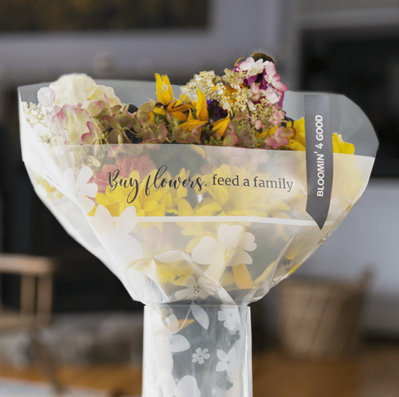

BLOOMIN’ 4 GOOD PROGRAM
Thank Your Supporters Email & Social Post
__________________________________________________________________________________________________________________________

DOWNLOAD IMAGES

SUBJECT: Thank you for your support!

Hello,

We are excited to share that $[money raised] was donated to our organization through the Stop & Shop Bloomin’ 4 Good Program during the month of [month of selection]!

We would like to extend a HUGE thank you for your participation and support during our benefiting month of the Stop & Shop Bloomin’ 4 Good Program.

Whether you bought a Bloomin’ 4 Good Bouquet or helped to spread the word, we couldn’t have done this without you. The money generated through this program will help us to [share what you will do with the funds raised]. Thank you again for making this a fun and successful experience for [name of organization]!

Share With Your Followers

Thank YOU! We raised $[donation amount] for [organization name] to fight hunger in our local community! Thank you to all who purchased a $10.99 bouquet in the sleeve marked “Bloomin’ 4 Good” this month. We couldn’t have done this without you!

stopandshop.2givelocal.com

