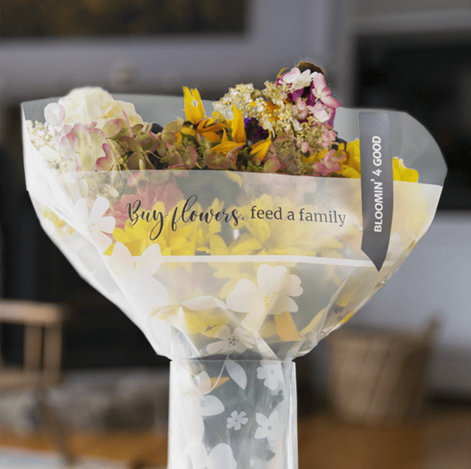

BLOOMIN’ 4 GOOD PROGRAM
Sample Press Release

__________________________________________________________________________________________________________________________

CLICK HERE FOR MARKETING MATERIALS

FOR IMMEDIATE RELEASE: [Name of organization] [Name, phone & email]

[Name of organization] has been selected as May’s Stop & Shop Bloomin’ 4 Good Program beneficiary.

[City, State] – For the entire month of May, [Name of organization] will receive $1 donation from every bouquet with the sleeve marked “Bloomin’ 4 Good” sold at Stop & Shop’s [location] location.

The Stop & Shop Bloomin’ 4 Good Program is an easy way for shoppers to give back to their communities. Every month, leadership at each Stop & Shop store selects a local hunger organization to benefit from every $10.99 Bloomin’ 4 Good bouquet sold in sleeves marked with the Program’s name. Since its launch in February 2021, the Program has donated over $850,000 to more than 2,000 hunger organizations.

“Brighten someone’s day while giving back locally!” said [name], Executive Director of [name of organization]. “Purchasing a Bloomin’ 4 Good Bouquet at [town’s] Stop & Shop in May will help our organization serve our community better.”

[Name of organization] is a nonprofit based in [city, state]. Founded in [year], [name of organization] has [describe efforts in the community]. Learn more about [name of organization] by visiting [website].

For more information about the Stop & Shop Bloomin’ 4 Good Program, please visit stopandshop.2givelocal.com.

stopandshop.2givelocal.com

