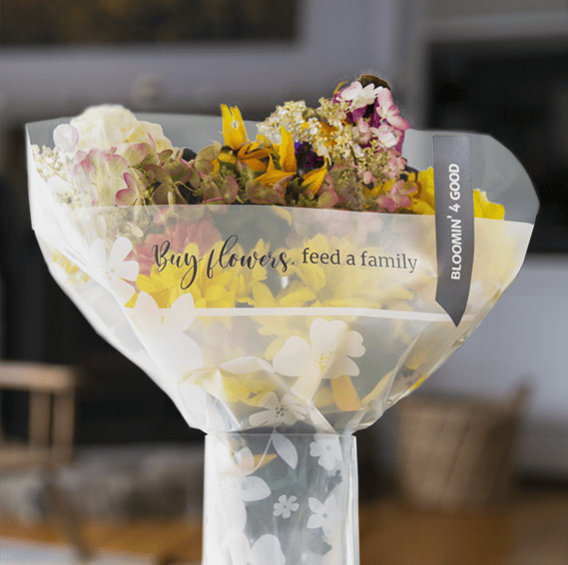

BLOOMIN’ 4 GOOD PROGRAM
Announcement Email

________________________________________________________________________________________________________________________________________

Subject Line: Buy a bouquet, and we’ll get $1 from Stop & Shop!

Preview Text: During [Month], we will receive $1 for every Bloomin’ 4 Good bouquet purchased at Stop & Shop!

Dear [Staff/Board/Volunteers/Supporters],

We are so excited to share that, for the entire month of [month], [organization] has been selected by store leadership to benefit from the Stop & Shop’s Bloomin’ 4 Good Program, created to fight hunger across the communities served by Stop & Shop.

For the month of [month], the purchase of a $10.99 bouquet in the sleeve marked “Bloomin’ 4 Good” from the Stop & Shop at [location] will brighten a home or make someone’s day while also directing a $1 donation to [organization].

This is a great way to broaden awareness in the local community and raise donations for our organization to help fight hunger. Since the program’s launch in February 2021, more than $1.2 million has been donated to more than 2,500 hunger organizations.

Let’s get started! Share the news with friends and family. Call, send emails, and post on social media. The more bouquets sold, the greater the donation we will receive from Stop & Shop!
To learn more about this program, please visit stopandshop.2givelocal.com.

Best,
[Signature]

