

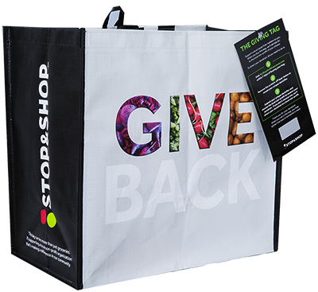**COMMUNITY BAG PROGRAM**

Announcement Email

**Subject Line:** We’ve been selected by the Stop & Shop Community Bag Program!

**Preview Text:** During [*Month*], we will receive $1 for every reusable Community Bag purchased at Stop & Shop!

Dear [*Staff/Board/Volunteer/Supporters*],

We are so excited to share that, for the entire month of [*month*], [*organization*] has been selected by store leadership to benefit from Stop & Shop’s Community Bag Program, which makes it easy for shoppers to contribute to their local community.

Whenever a $2.50 reusable Community Bag is purchased at the Stop & Shop located at [*location*] in [*month*], $1 will be donated to [*organization*]. This is a great way to broaden awareness and help our cause.

Let’s get started! Share the news with friends and family. Call, send emails, and post on social media. The more people who purchase the Community Bag in [*month*], the greater the donation we will receive!

To learn more about this program, please visit [stopandshop.2givelocal.com](https://stopandshop.2givelocal.com/).

Best,

[*Signature*]