

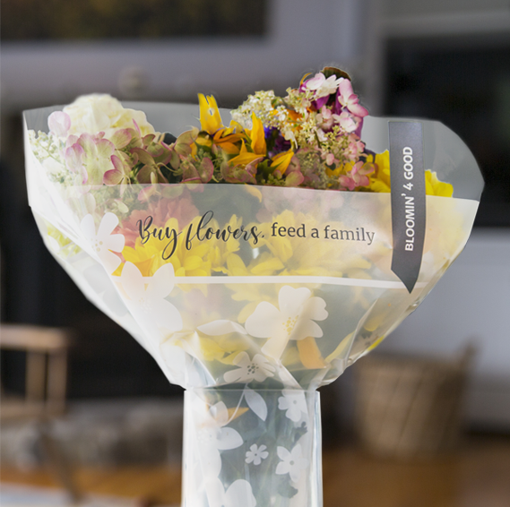

**BLOOMIN’ 4 GOOD PROGRAM**

Announcement Email

& Social Post

**SUBJECT LINE:** Buy a bouquet, and we’ll receive $1 from Stop & Shop!

**PREVIEW TEXT:** During [*Month*], for every Bloomin’ 4 Good bouquet purchased at Stop & Shop,   
we receive a $1 donation!

Dear [*Staff/Board/Volunteers/Supporters*],

We are so excited to share that, for the entire month of [*month*], [*organization*] has been selected by store leadership at Stop & Shop’s [location] to receive a $1 donation from every purchase of the specially marked $11.99 Bloomin’ 4 Good bouquet. This is a great way to broaden awareness and help our cause.

Flowers can make someone’s day, brighten a room, or spread a smile. Now they can give back to our local communities, too. The Bloomin’ 4 Good Program, which was launched in February 2021, is an easy way for shoppers to support local nonprofit organizations.

Let’s get started! Share the news with friends and family. Call, send emails, and post on social media. The more bouquets sold, the larger the donation we will receive!

To learn more about this program, please visit <stopandshop.2givelocal.com>.

Best,

[*Signature*]



**Share With Your Followers**

**We’re excited that Stop & Shop has selected our organization to benefit from the Bloomin’ 4 Good Program! Throughout [*month*], we will receive a $1 donation for every specially marked $11.99 Bloomin’ 4 Good bouquet purchased at the Stop & Shop located at [*address of selected store(s)*].**