

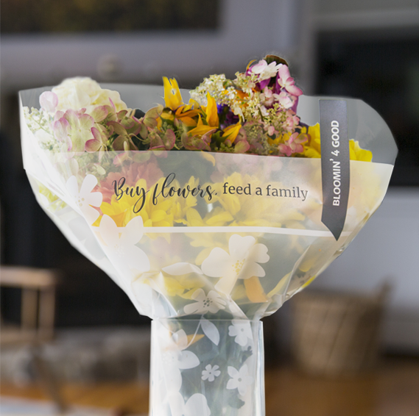

BLOOMIN’ 4 GOOD PROGRAM

Launch Day Email

& Social Post

**SUBJECT:** Launch day for the Stop & Shop Bloomin’ 4 Good Program partnership!

**PREVIEW TEXT:** Let’s start raising donations today!

Good morning,

Today is the first day of [*month*], which means it is our first day benefiting in the Stop & Shop Bloomin’ 4 Good Program! Starting today and for the entire month of [*month*], our organization will receive a $1 donation for every specially marked $11.99 Bloomin’ 4 Good bouquet purchased at the Stop & Shop located at [*location*].

Flowers can make someone’s day, spread smiles, and brighten up a room. For this month, they can also help [*name of organization*] serve someone in need.

Please help us spread the word in our community! Share this news with family and friends, post on social media, email supporters, and get the word out.

A bouquet of flowers is a great gift. This program makes it possible to make someone’s day and support our organization and community at the same time.

The specially marked $11.99 Bloomin’ 4 Good bouquets are in the floral section of the store. For more information about this program, please visit <stopandshop.2givelocal.com>.

Thank you for your support!

Best,

[*Signature*]



**Today, we start benefiting from the Stop & Shop Bloomin’ 4 Good Program! This month, our organization will receive a $1 donation for every specially marked $11.99 Bloomin’ 4 Good bouquet purchased at the Stop & Shop(s) located at [*store* *address(es)*].**

share with your followers