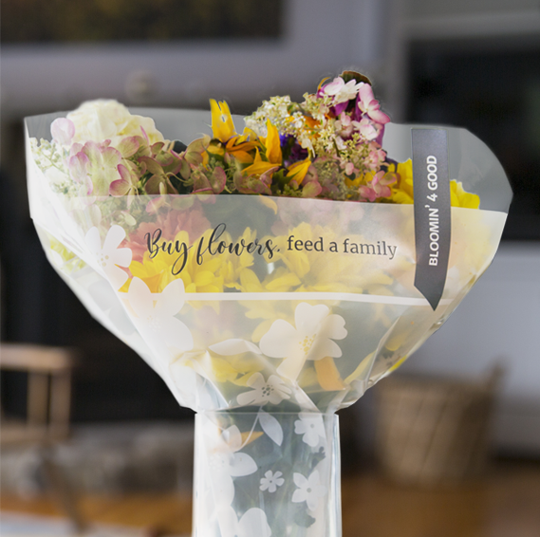



BLOOMIN’ 4 GOOD program

Thank Your Supporters  
 Email & Social Post

**SUBJECT:** We appreciate your support!

**PREVIEW TEXT:** Thank you for participating in the Stop & Shop Bloomin’ 4 Good Program.

Good morning,

We are excited to announce that [*name of organization*] will receive $[*donation amount*] in donations from our partnership with the Stop & Shop Bloomin’ 4 Good Program during [*month*].

Thank you for your participation and support during our benefiting month of the Stop & Shop Bloomin’ 4 Good Program. Whether you bought a Bloomin’ 4 Good bouquet or helped spread the word, we couldn’t have done this without you!

The money we receive from Stop & Shop will help us to [*share what you’ll do with the donations*]. Thank you again for making this a fun and successful experience for [*name of the organization*].

Best,

[*Signature*]



Share With Your Followers

**We are happy to announce that, thanks to your support, we will receive $[*donation amount*] from our Stop & Shop Bloomin’ 4 Good Program partnership. We couldn’t have done this without you! Your support helps us continue to make a difference in our community!**