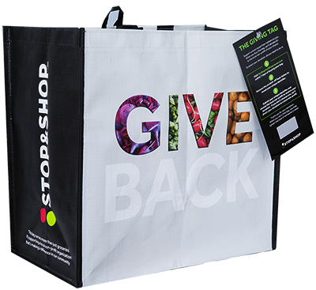



**COMMUNITY BAG PROGRAM**

Fact Sheet

Congratulations on your organization’s selection in the Stop & Shop Community Bag Program!

**Not sure how to start talking about the program? We’re here to help!** We’ve brought together key facts and talking points from across the program website compiled in one place. Below you will find information you can use to discuss this program with your board, staff, and supporters:

1. The Stop & Shop Community Bag Program has been operating since May 1, 2019.
2. Since inception, the program has donated $3,322,354 to 7,518 nonprofit organizations and sold 3,322,321 reusable bags. *
3. Stop & Shop operates 357 stores across Connecticut, Massachusetts, New Jersey, New York, and Rhode Island that participate in the program.
4. The Stop & Shop Community Bag Program makes it easy for shoppers to support their communities and environment by buying durable, reusable shopping bags. A portion of each purchase goes to a local nonprofit organization focused on education, civic, health & wellness, hunger relief, or military/veterans.
5. Every month, the Store Leadership Team at each Stop & Shop location chooses a local nonprofit to be the monthlong beneficiary of the Community Bag Program in that store. Different nonprofits are selected every month to ensure the many organizations making a difference in our local communities can be supported by this program. The name of the organization is displayed on the reusable bag rack during their benefiting month.
6. Generally, the nonprofits selected by a specific store are within a 10-mile radius of that store location. It’s important to note that this program benefits each store’s regional shopping area.
7. Each bag costs $2.50, with $1 of that purchase going to support a benefiting nonprofit in your community.

________________________________________

*\*As of 5.10.25. These statistics are updated daily on the program website and can be found* [***here***](https://stopandshop.2givelocal.com/program/community-bag/)*. You will want to use the most recent data available at the time of your selection.*

**Page 2**

1. Nonprofits meeting the [**program's qualifications**](https://stopandshop.2givelocal.com/submit-your-organization/) are submitted to our database of thoroughly researched organizations within the vicinity of each store location
2. A list of nonprofit organizations that have benefited from the Community Bag Program can be found [**here**](https://stopandshop.2givelocal.com/community-impact-by-non-profit/) on the program website and is organized alphabetically.
3. The bags are made from 95% recycled materials from either nonwoven or woven polypropylene. They are manufactured in Vietnam in factories that follow the strictest guidelines for employment and production standards.

*Published 5.12.2025*