
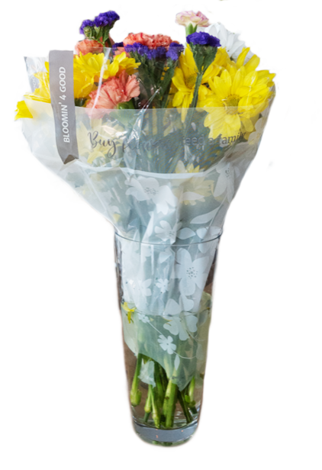

BLOOMIN’ 4 GOOD PROGRAM

Reminder Email

SUBJECT: We have [insert number of weeks or other time frame] weeks remaining
in our Stop & Shop Bloomin’ 4 Good Program partnership!
PREVIEW TEXT: There’s still time to maximize this opportunity for our cause!

Good morning,
We've reached [or We will shortly reach] the halfway point in our [insert month] partnership with the Stop & Shop Bloomin’ 4 Good Program. This is a wonderful opportunity to raise funds for our organization, spark positive change in our community, and help feed those in need!
Remember, for every specially marked $11.99 Bloomin’ 4 Good bouquet purchased at [insert location] this month, we'll receive $1. Every bouquet counts, so let's maximize this opportunity!
Please spread the word to your friends and family. Let's encourage everyone to look for the Stop & Shop Bloomin’ 4 Good bouquets in our selected store(s) this month. There’s still time left to make a difference!
For more information about this impactful program, please visit stopandshop.2givelocal.com.
Thank you for your support!
Best,
[Signature]

