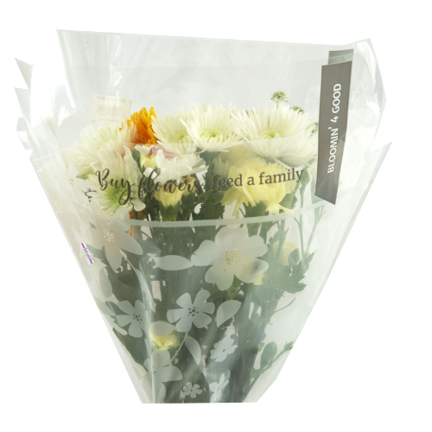



Reminder Email

SUBJECT: We’re almost halfway there; let’s keep the momentum going!
PREVIEW TEXT: There’s still time to make an even bigger impact for our community.

Good morning,

We’re approaching the halfway point of our monthlong partnership with the Stop & Shop Bloomin’ 4 Good Program. Thanks to your support, we’re already making a difference. Now is the time to keep that momentum strong.
For every specially marked $11.99 Bloomin’ 4 Good bouquet purchased at [insert location(s)] during [month], we receive $1 to support our mission. Each bouquet purchase represents a simple action with real impact, sparking positive change in our community and helping those in need.
There’s still time to grow what we’ve started!

Please help us spread the word. Share with your friends, family, and community, and
remind them to look for specially marked $11.99 Bloomin’ 4 Good bouquets at our
selected store(s).

Together, we can turn a bouquet purchase into meaningful support.

Thank you for being part of this effort.

Gratefully,
[Signature]

