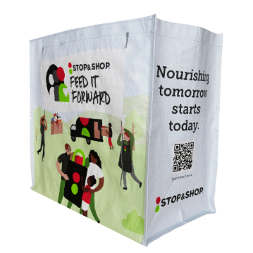



Launch Day Email

SUBJECT: It starts today! Help us make a difference, one Community Bag at a time.
PREVIEW TEXT: Every bag purchased supports our mission in a meaningful way.

Good morning,

Today marks the beginning of something meaningful. We’re honored to partner with the Stop & Shop
Community Bag Program, and starting today, you have a simple way to help make a real difference.
Throughout [month], every $2.50 reusable Community Bag purchased at the Stop & Shop located at [address(es) of selected store(s)] will direct $1 to [name of organization]. Each bag may seem small, but together they add up to something powerful.
We’ve set a goal to raise $[total], and with your support, we know it’s possible.
You can help today by:

- Choosing a Community Bag at our selected Stop & Shop when you’re shopping.
- Sharing this opportunity with your friends and family.
- Encouraging others to support us while they shop.

Because of you, more individuals and families will have access to the resources they need. Thank you for standing with us, and for helping turn everyday choices into meaningful impact.

Gratefully,
[Signature]

